BATCH CODE 2301B3 E-PROJECT

**e-Project Docuemnttation**

src travel agency

**Project Instructor**

**Sir wali muhammad**

**Curriculum Code**

7062

**Coordinator**

Miss maham haider

**Group Members**

|  |  |
| --- | --- |
| Student1445925 | Malik Hassan Nawaz |
| Student1446481 | Talha Faiz |
| Student1451018 | Saif Ali Brohi |
| Student1446480 | Muhammad Asfahan |

|  |  |
| --- | --- |
| Student1452428 | Muhammad Arsalan |

# 



# Snap Shots

***HOME:***







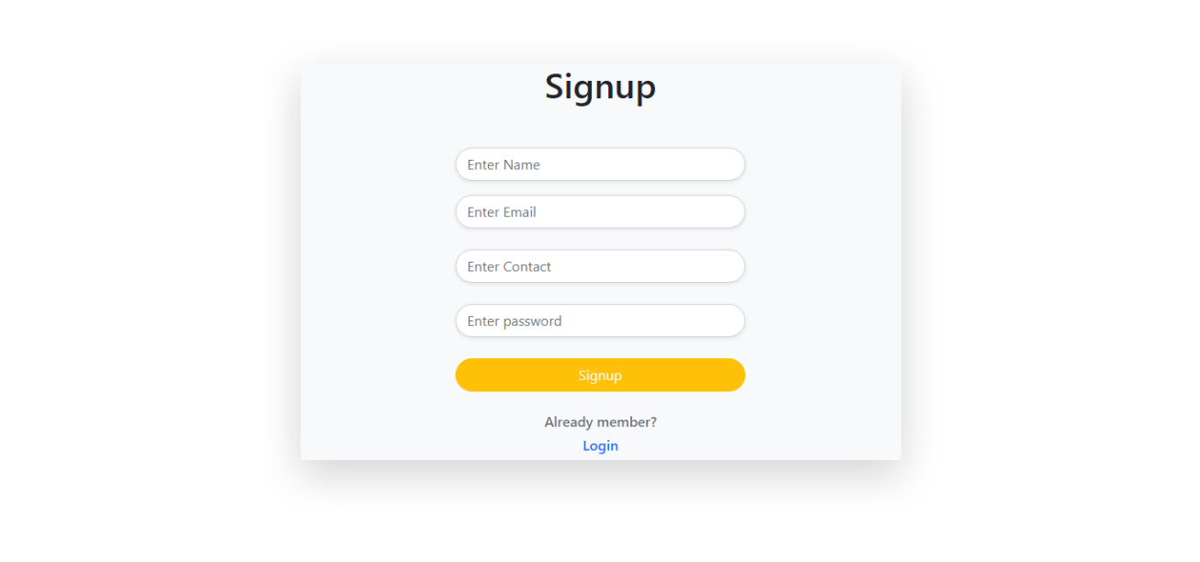

***LOGIN/  
REGISTER:***

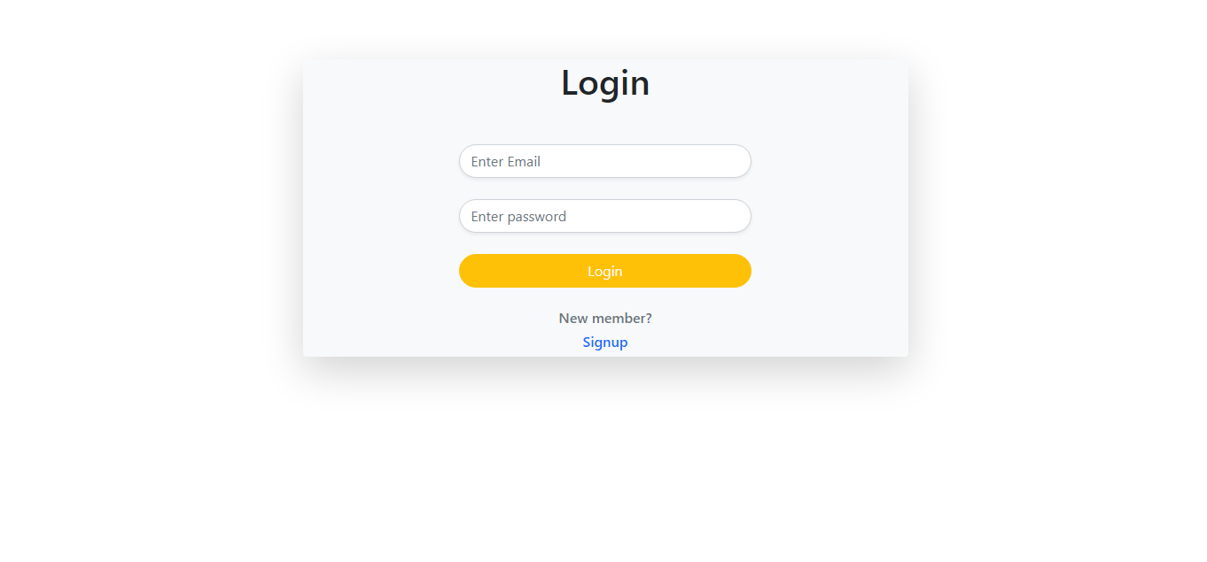

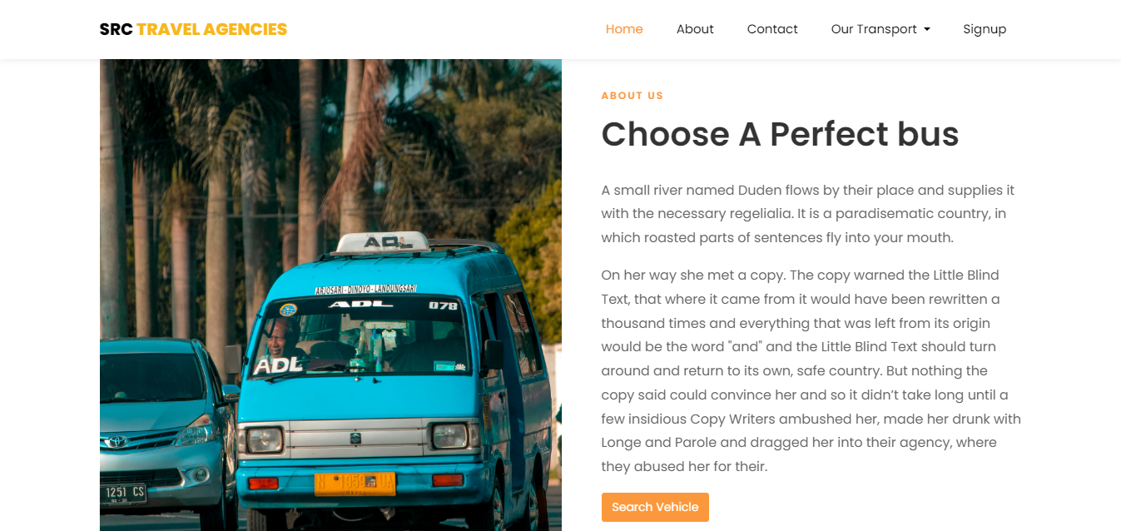

***ABOUT US:***



***ADMIN PANEL:***

